STUDENT PERFORMANCE
EXPLORATORY DATA ANALYSIS (EDA)
INTERNSHIP TASK 3 REPORT

Project: Exploratory Data Analysis of Student Performance Using Python
Prepared by: Asane Shubhangi Bhimraj
Tools: Python, Pandas, NumPy, Matplotlib, Seaborn

1. Introduction
Exploratory Data Analysis (EDA) is the process of inspecting, summarizing, and visualizing data to understand its structure and discover patterns. This project explores a sample student performance dataset to examine the relationships among daily study hours, attendance, assignment scores, and exam marks.

2. Objectives
- Inspect the structure and columns of the dataset.
- Check the dataset for missing values and duplicate rows.
- Calculate summary statistics for study hours, attendance, assignment scores, and exam marks.
- Visualize distributions and relationships using charts.
- Measure correlations with exam marks.
- Group students into Low, Medium, and High performance categories.

3. Tools and Technologies
Python; Pandas; NumPy; Matplotlib; Seaborn; Jupyter Notebook / Google Colab.

4. Dataset Description
The notebook creates a sample dataset containing 20 students and 5 original columns. The exported CSV also includes a derived Performance_Level column added during the analysis.
Column | Meaning | Type
Student_ID | Unique student identifier | Integer
Study_Hours | Daily study hours | Integer
Attendance | Attendance percentage | Numeric
Assignment_Score | Assignment score | Numeric
Exam_Marks | Exam marks | Numeric
Performance_Level | Category derived from exam marks | Categorical (added during analysis)

Dataset shape reported in the notebook: 20 rows × 5 columns before the derived Performance_Level column was added.

5. Methodology
- Imported Pandas, NumPy, Matplotlib, and Seaborn.
- Created the sample dataset and inspected the first and last records.
- Checked shape, column names, data types, missing values, and duplicate rows.
- Calculated descriptive statistics.
- Generated charts for marks distribution and relationships.
- Computed a correlation matrix and ranked factors correlated with exam marks.
- Categorized exam performance: Low (<40), Medium (40–69), High (70 or above).
- Exported the processed dataset to student_performance_eda.csv.

6. Data Quality Results

Check | Notebook result
Number of students | 20
Original columns | 5
Missing values | 0 in every original column
Duplicate rows | 0
Original column data types | All five columns reported as int64

7. Descriptive Statistics and Key Numerical Results

Metric | Actual result from notebook
Average study hours | 5.30 hours
Average attendance | 77.15%
Average assignment score | 65.65
Average exam marks | 63.60
Highest exam marks | 96
Lowest exam marks | 35
Total students | 20

The average exam score is 63.60, with scores ranging from 35 to 96. The sample dataset has an average of 5.30 study hours and 77.15% attendance.

8. Graphs and Interpretation
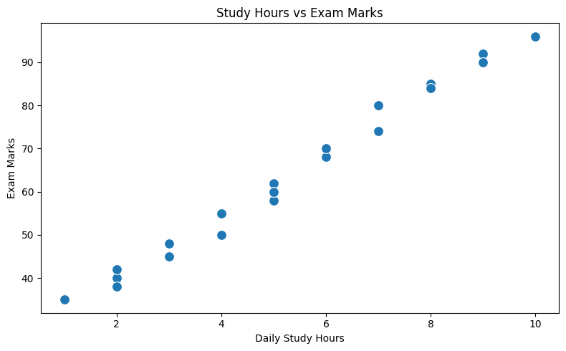

Figure 1. Study Hours vs Exam Marks

The scatter plot compares daily study hours with exam marks. In this sample, students with more study hours generally have higher exam marks; this is an observed association, not proof of causation.
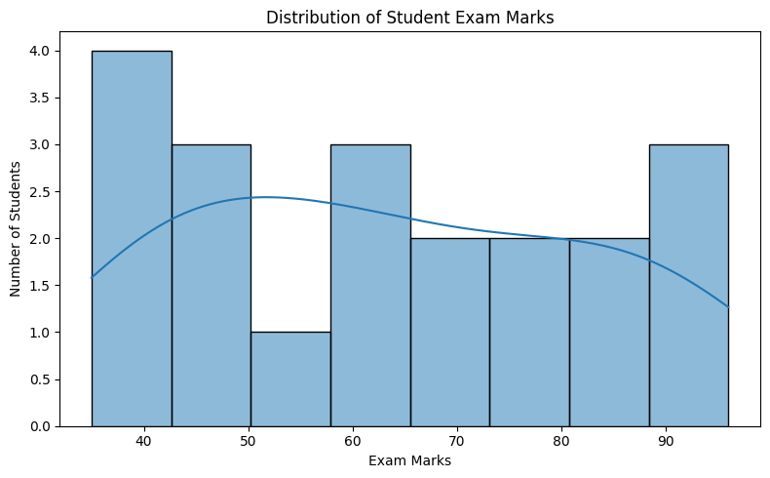

Figure 2. Distribution of Student Exam Marks

The histogram displays how exam marks are distributed across students. It helps identify where scores are concentrated and how widely the marks vary.

Figure 3. Study Hours vs Exam Marks

The scatter plot compares daily study hours with exam marks. In this sample, students with more study hours generally have higher exam marks; this is an observed association, not proof of causation.
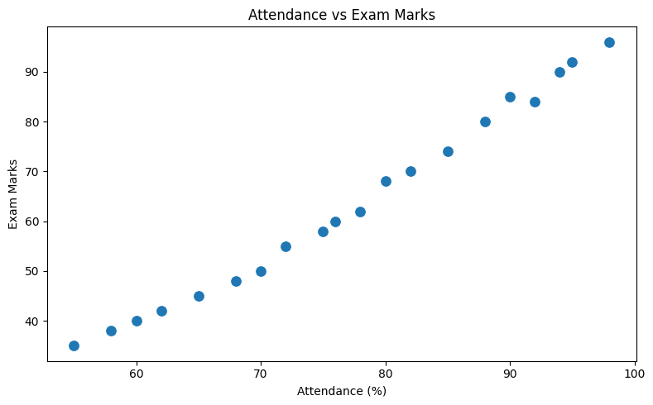

Figure 4. Attendance vs Exam Marks

The scatter plot compares attendance percentage with exam marks. The sample shows a strong positive association: higher attendance tends to accompany higher exam marks.
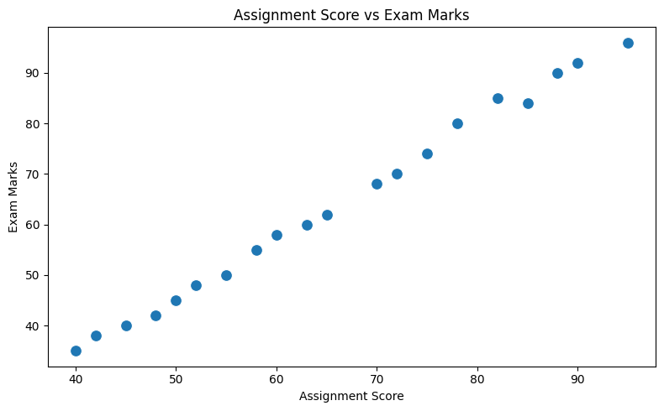

Figure 5. Assignment Score vs Exam Marks

The scatter plot compares assignment scores with exam marks. The points show a very strong positive association between assignment performance and exam results.
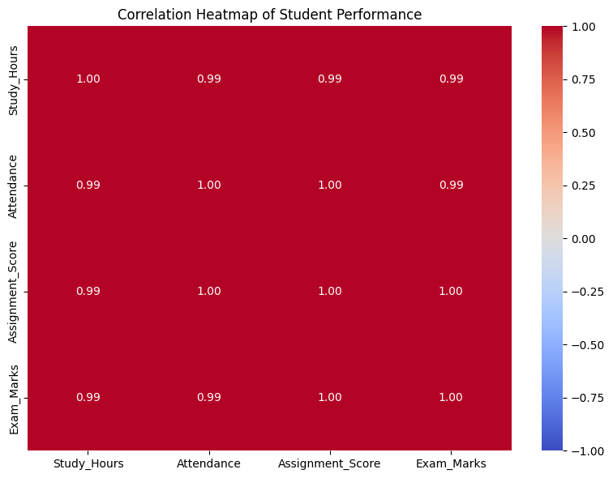

Figure 6. Correlation Heatmap of Student Performance

The heatmap summarizes pairwise correlations among study hours, attendance, assignment scores, and exam marks. Values closer to +1 indicate a strong positive linear relationship.
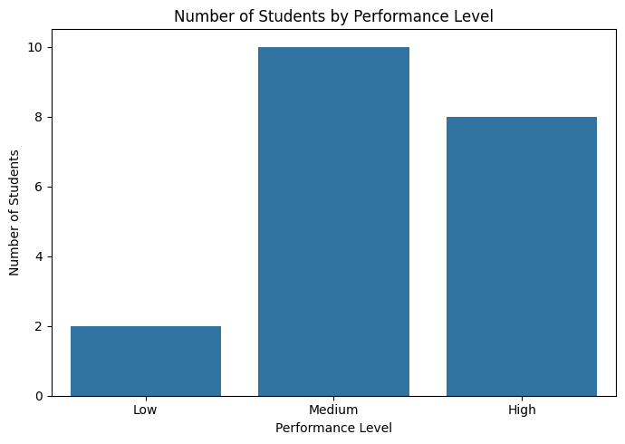

Figure 7. Number of Students by Performance Level

The bar chart summarizes the number of students in each performance category. The notebook reports 10 Medium, 8 High, and 2 Low performers.

9. Correlation Analysis

Variable compared with Exam_Marks | Correlation coefficient
Assignment_Score | 0.998076 (≈ 0.998)
Attendance | 0.994506 (≈ 0.995)
Study_Hours | 0.994195 (≈ 0.994)

Assignment_Score is the most positively correlated variable with Exam_Marks in this dataset (r ≈ 0.998). Attendance (r ≈ 0.995) and Study_Hours (r ≈ 0.994) also show very strong positive correlations. Because this is a small, constructed sample dataset, these correlations should not be generalized to all students or interpreted as proof that one variable causes another.

10. Student Performance Categories
The notebook assigns categories based on exam marks: Low for marks below 40, Medium for marks from 40 to below 70, and High for marks of 70 or above.
Performance category | Number of students
Low | 2
Medium | 10
High | 8
Total | 20
Medium is the largest category, representing 10 of the 20 students. Eight students are in the High category, while two are in the Low category.

11. Overall Results and Discussion
- The dataset contains 20 students and 5 original numeric columns.
- The missing-value check found no missing values, and the duplicate check found zero duplicate rows.
- Average exam marks are 63.60; the highest score is 96 and the lowest is 35.
- Assignment score has the strongest positive correlation with exam marks (approximately 0.998).
- Attendance and study hours also have very strong positive correlations with exam marks in this sample.
- The performance grouping contains 10 Medium, 8 High, and 2 Low students.
- The graphs support visual inspection of the score distribution and the relationships between study habits, attendance, assignments, and exam results.

12. Conclusion
This project demonstrates a complete basic EDA workflow using Python. The dataset was inspected, checked for missing values and duplicates, summarized statistically, visualized, and analyzed using correlation coefficients. In this sample, assignment scores, attendance, and study hours are all strongly and positively associated with exam marks, with assignment score showing the strongest association. These findings describe this sample only and should not be treated as universal conclusions.

13. Future Scope
- Use a larger real-world student dataset to improve representativeness.
- Explore outliers and additional descriptive statistics.
- Compare relationships across student groups if suitable demographic or academic variables are available.
- Build a carefully validated predictive model only if a suitable real dataset and evaluation design are available.

14. References
- Python documentation: https://docs.python.org/3/
- Pandas documentation: https://pandas.pydata.org/docs/
- NumPy documentation: https://numpy.org/doc/
- Matplotlib documentation: https://matplotlib.org/stable/
- Seaborn documentation: https://seaborn.pydata.org/

